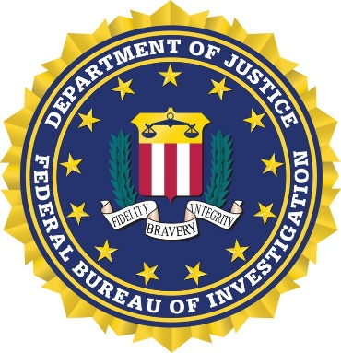

35th ANNUAL FBI “STEAK OUT”
Join us for an evening of social relaxation and good food at the 35th Annual FBI Steak Out.
We look forward to this opportunity to meet with our many friends.

MONDAY, August 18, 2025
OLD SHAWNEE “TOWN HALL”
11600 JOHNSON DRIVE
SHAWNEE, KANSAS 66203
$35 PER PERSON
CASUAL DRESS (NO SHORTS)

SOCIAL HOUR 5:00 P.M.—6:00 P.M.
DINNER SERVED 6:15 P.M.

*REGISTRATION MUST BE RECEIVED BY AUGUST 6, 2025*

PLEASE SEND REGISTRATION FORM AND PAYMENT TO:
FBI KANSAS CITY
TRAINING OFFICE
11180 NW PRAIRIE VIEW ROAD
KANSAS CITY, MO 64153

(CHECKS MADE PAYABLE TO FBINAA)
(Info to pay via credit card on next page)

*FBI National Academy Members ONLY: Register on the chapter website at fbinaakswmo.org
________________________________________________________________________
PLEASE PRINT - NAME TAGS WILL BE MADE
NAME____________________________________________________________
COMPANY/DEPARTMENT_______________________________________________
EMAIL ADDRESS______________________________________________________
GUEST NAME AND COMP./DEPT.__________________________________________
GUEST NAME AND COMP./DEPT.__________________________________________
SESSION # (IF APPLICABLE) _________________

FBI STEAK OUT
August 18, 2025

PLEASE INVOICE ME

Attendee Name(s):___________________________________________________________

Name of person to be invoiced: ___________________
Billing address: ________________________________

City/State/Zip: _________________________________

Email address (for receipt): _______________________

Telephone #____________________________________

