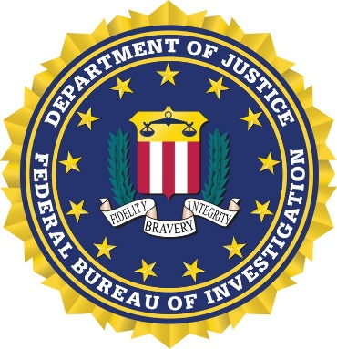

32nd ANNUAL FBI “STEAK OUT”
Join us for an evening of social relaxation and good food at the 32nd Annual FBI Steak Out.
We look forward to this opportunity to meet with our many friends.

THURSDAY, JUNE 30, 2022
OLD SHAWNEE “TOWN HALL”
11600 JOHNSON DRIVE
SHAWNEE, KANSAS 66203
$25 PER PERSON
CASUAL DRESS (NO SHORTS)

SOCIAL HOUR 5:00 P.M.—6:00 P.M.
DINNER SERVED 6:15 P.M.

REGISTRATION MUST BE RECEIVED BY JUNE 17, 2022*

PLEASE SEND REGISTRATION FORM AND PAYMENT TO:
FBI KANSAS CITY
TRAINING OFFICE
1300 SUMMIT STREET
KANSAS CITY, MO 64105

(CHECKS MADE PAYABLE TO FBINAA)
(Info to pay via credit card on next page)

*FBI National Academy Members ONLY: Register on the chapter website at fbinaakswmo.org
________________________________________________________________________
PLEASE PRINT - NAME TAGS WILL BE MADE
NAME____________________________________________________________
COMPANY/DEPARTMENT_______________________________________________
EMAIL ADDRESS______________________________________________________
GUEST NAME AND COMP./DEPT.__________________________________________
GUEST NAME AND COMP./DEPT.__________________________________________

FBI STEAK OUT
June 30, 2022

CREDIT CARD PAYMENT

Attendee Name(s):___________________________________________________________

Card #:______________________________________________ Expires:_________

Name: ________________________________________

Billing address: ________________________________

City/State/Zip: _________________________________

Email address (for receipt): _______________________

If you provide an email address a purchase receipt will be emailed to you.

Credit card payment can be made by mail (include with registration), email, or phone
to Mr. Steve Cox, FBINAA Kansas/Western Missouri Chapter Secretary Treasurer.

EMAIL TO: sectreaskswmo@gmail.com

MAIL TO (include registration information):
Mr. Steve Cox
21287 W. 116th St.
Olathe, KS 66061-6502

PAY BY PHONE: 913.201.1153 – call and leave a message for a return call.

If not paying via credit card, SEND REGISTRATION and PAYMENT/CHECKS MADE PAYABLE TO FBINAA to:
FBI KANSAS CITY
TRAINING OFFICE
1300 SUMMIT STREET
KANSAS CITY, MO 64105

